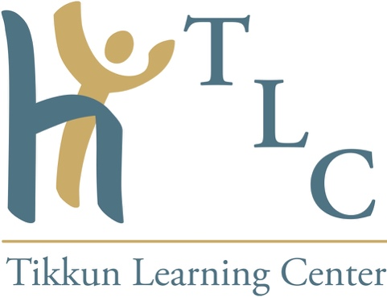

Hedy Schleifer, MA, LMHC

Hedy Schleifer was born in Lausanne, Switzerland, raised in Antwerp, Belgium, and lives currently in the USA. She studied Psychology at UCLA and received her degree in Clinical Psychology at Tel Aviv University in Israel. She dedicates her professional life to the exploration of the relational paradigm, and the development of relational intelligence and maturity in couples. With this in mind she developed Encounter-centered Couples Therapy, (EcCT), an innovative, integrative and transformational approach for the creation of solid, productive and creative relationships. Hedy founded the Tikkun Learning Center, educating Couples, Mental Health Professionals as well as Executives in the power of connection. (Tikkun is Hebrew for the potent merging of the elements of re-pair, healing, transformation and completion.) Hedy is often called the “therapist’s therapist" by her colleagues. With her husband Yumi, Hedy travels extensively throughout the world, bringing their passion and expertise in the “art of relationships” and “conflict dissolution” in English, French, German and Hebrew. As a result of their international activities, they have been described by one of their students as the “itinerant mystics.” They live in Washington, DC, and have two sons, and 13 grandchildren.

